Orbital Shaker—MPS-20
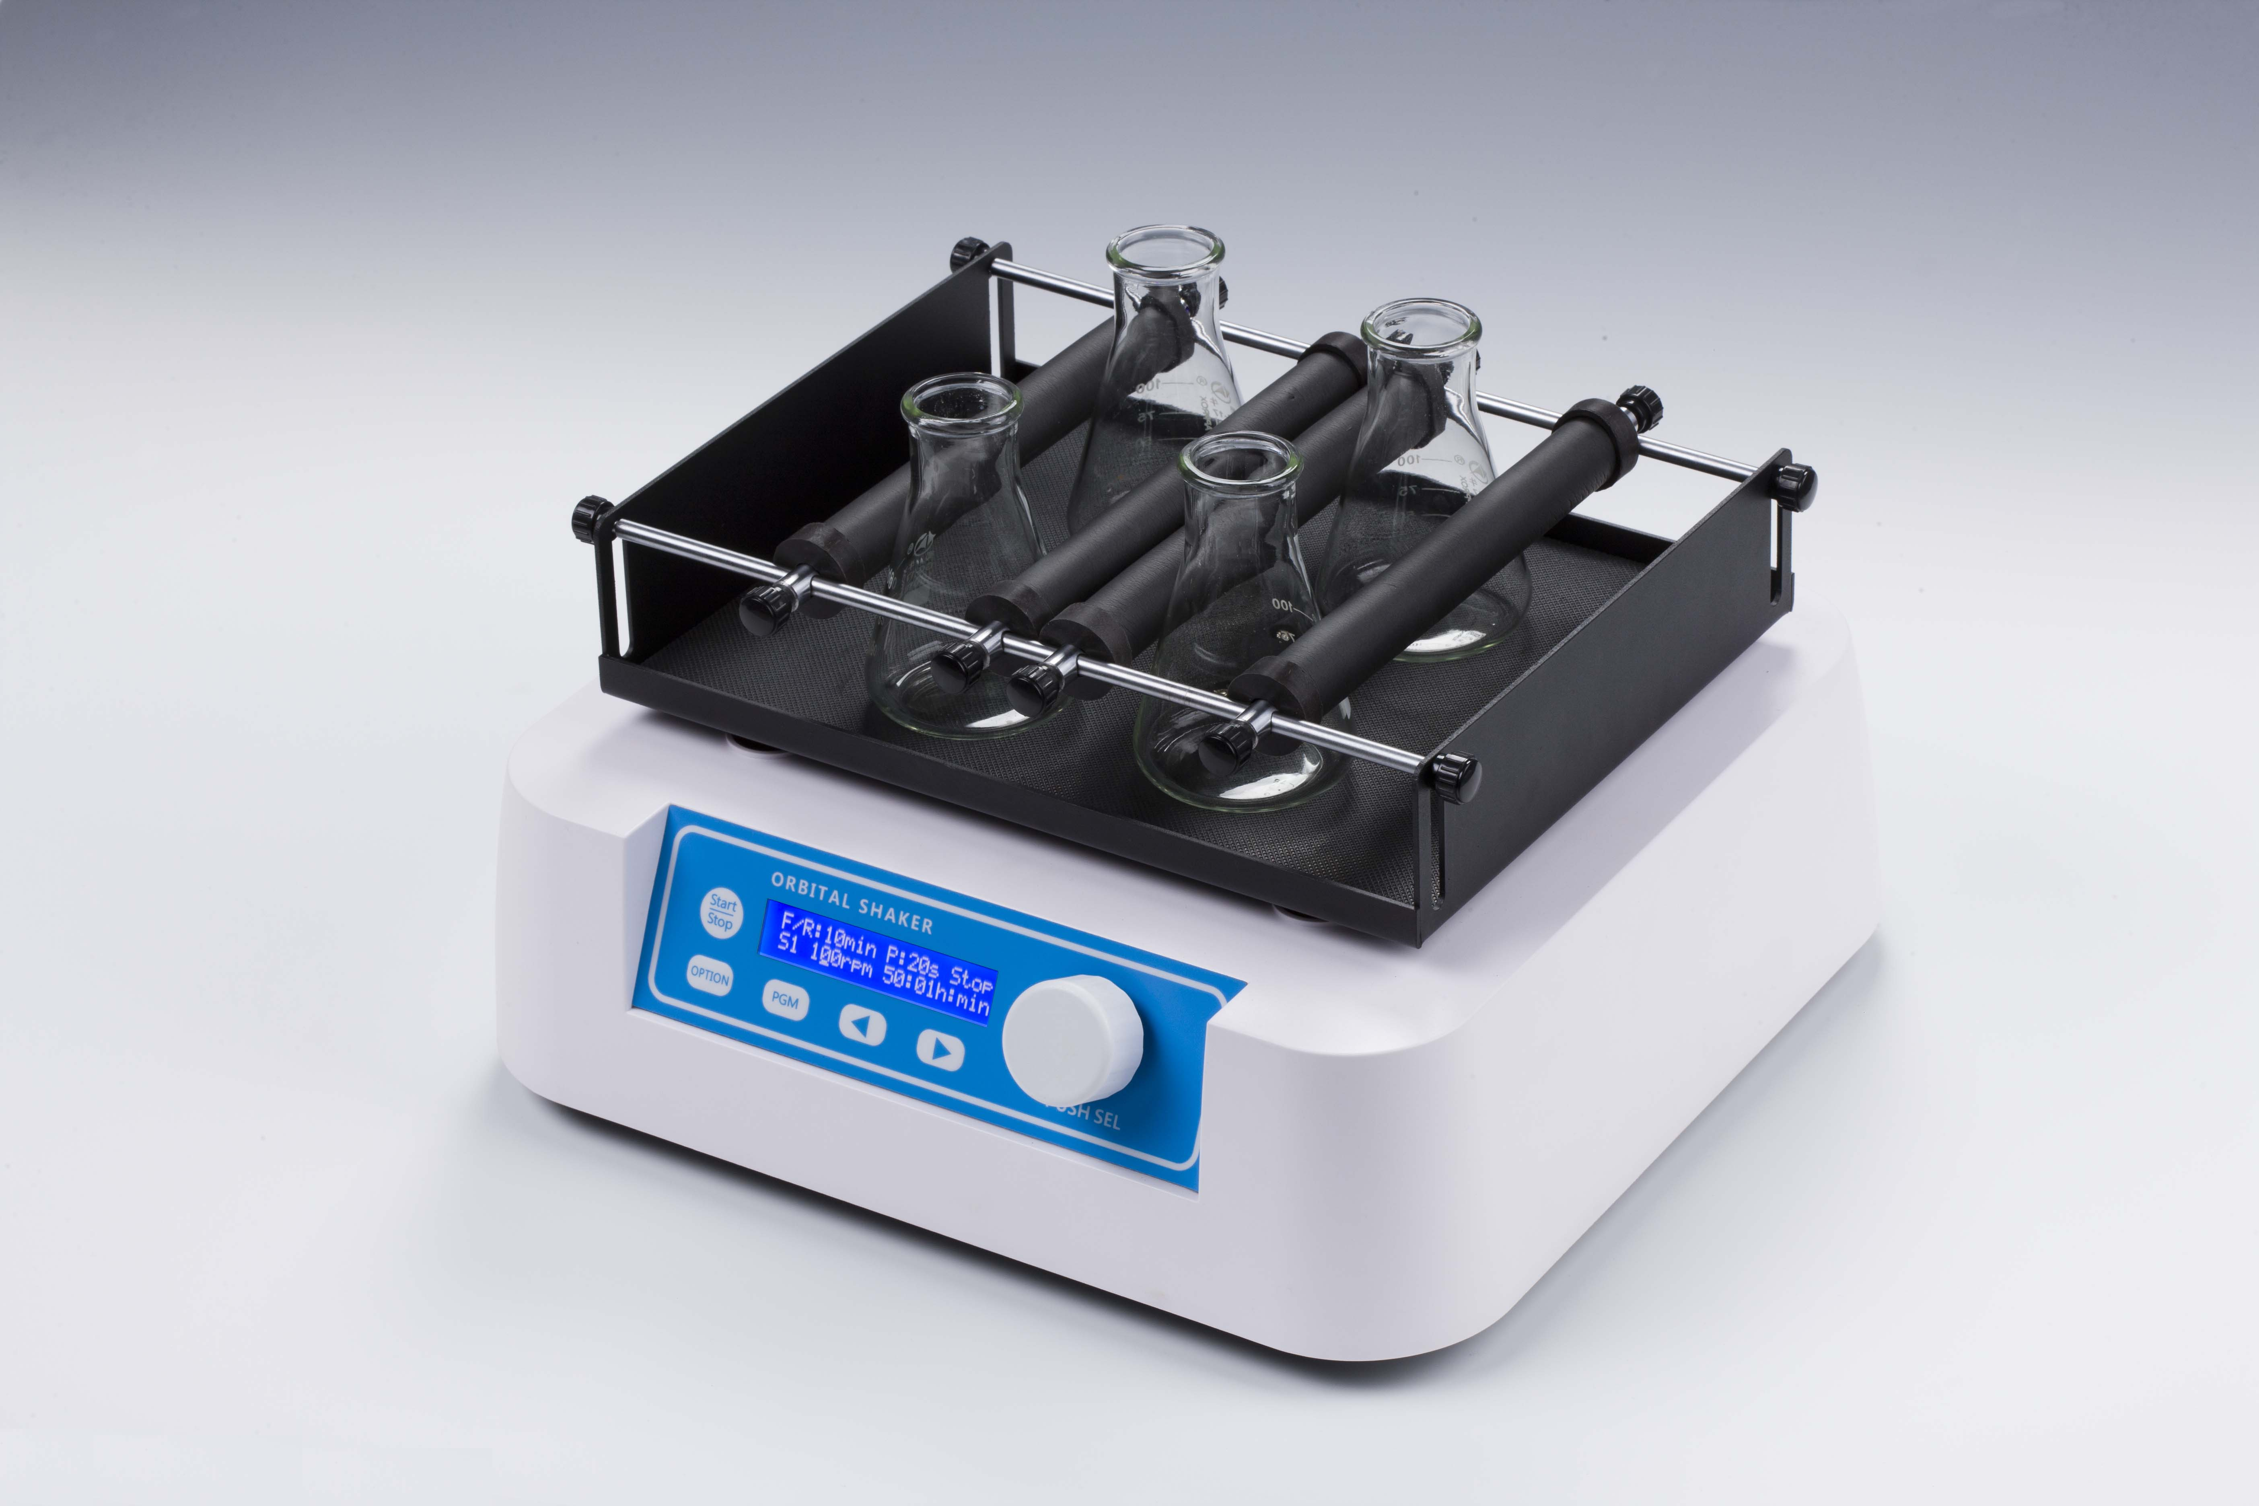

Description:
MPS-20 Orbital Shaker is a high speed shaker with brushless DC motor and microprocessor controlled technique. Mix and culture all kinds of flask, petri dish and beaker, by changing different platforms. It can be applicable in different laboratories: biotechnology, microbiology and medicine analysis, etc.

Features：
- LCD displays time and shaking speed.
- With special Forwards/Reverse shaking and pause function, it can be shaking intermittently.
- Beep alarm when operation ends.
- Different platforms can be chosen for variety demands.
- Soft start, uniform acceleration, effectively avoid splash sample.
- Gentle and reliable shaking with direct brushless DC motor.

Parameters:
Type  Parameter | MPS-20
Timing range | 1min~99h59min
Forwards/Reverse shaking | Yes
Timing range for Forwards/Reverse shaking | 0-99min
Timing range for pause | 0-99sec
Shaking speed | 50~250rpm
Orbit | 20mm
Max. load | 2.5kg
Power | 35W
Votltage | AC110~240V, 50/60Hz
Dimension(with PP-1)(mm) | 280×270×110
Weight(with PP-1)(kg) | 8.2

Optional Platforms
Type | Description
PP-1 | Flat platform for 8pcs petri dish
PP-2 | Universal platform with adjustable bars, for 6x100ml or 4x250ml conical flask
PP-3 | Platform with clamps for 12x100ml conical flask
PP-3 | Platform with clamps for 6x250ml conical flask

